1. Create a list called *friends* which contains the names Joey, Ross, Monica, Chandler, Rachel and Phoebe. Print the whole list
2. Create a list called friends with the same names from exercise 1  
   Print the first name that appears on the list (Joey)
3. Create a list called friends with the same names from exercise 1  
   Ask the user for their name and add it to the end of the list  
   Print the list
4. Create a list called vip_guests which contains the names Leonardo DiCaprio, Camila Cabello, Angelina Jolie, Shawn Mendes.  
   Ask the user for their name.  
   If the users name is on the guest list, print “Welcome to Monty’s Lounge”  
   If the users name is not on the guest list, print “Please wait for manager”
5. Create a list called groceries containing sugar, chips, water, tea, pencil,   
   Print out that each item in the list costs $1  
   Hint: You will need a for loop
6. The DMV has 100 customers which need to be randomly assigned to a random booth.  
   There are 8 booths in the DMV.

Create a program that assigns each customer to one of the 8 booths.

Sample Output:

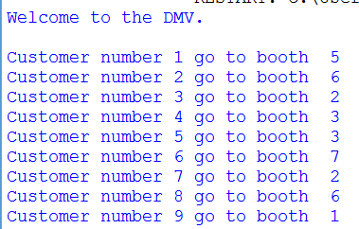

1. Create a list of ages: 31, 19, 27, 32, 45, 22